**Cassiltoun Trust’s Community Bursary Scheme**

**Application Form and Guidance**

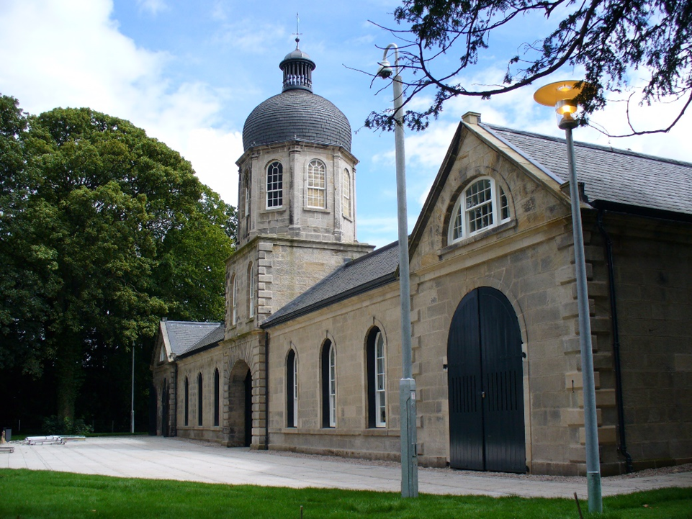

**Applications close 23/9/24 at 9am**

If you have any questions regarding this application or if you require this application in a different format (for example, another language, Braille, audio), you can contact us by calling 0141 631 5224 or emailing [community@cassiltoun.org.uk](mailto:community@cassiltoun.org.uk)

**Helpful information about the Community Bursary**

**Why is there a Cassiltoun Trust Community Bursary?**

The Cassiltoun Trust developed the Community Bursary as part of the Trust’s 10th Anniversary celebrations. The bursary was developed to directly invest in local people for 10 years to support them to reach their educational aspirations. In 2024 we will offer two bursaries of £500 to two local people accessing higher or further education.

**What is a bursary?**

This bursary is a one off sum that you are not expected to pay back. In return we do ask that the successful applicant meets with a staff member of the Cassiltoun Group to hear about the range of ways to get involved and to discuss the opportunities to do so.

**What can the bursary be used for?**

We expect the bursary to be used to support you to complete an educational course. Examples of costs could include; a laptop, textbooks, stationery, bus pass, course resources, childcare etc.

**Who can apply?**

To be eligible for the Cassiltoun Trust’s Community Bursary, you must fit all of the below criteria:

* You must not have received the Cassiltoun Trust Community Bursary in the past
* You must be a current resident of the G45 area in Glasgow and have been accepted in to higher or further education, for example college or university degrees
* You must be 16 or over
* You must not be an immediate relative of any one who is employed by the Cassiltoun Group (by ‘immediate relative’ we mean, parent, spouse, child, or sibling)
* You must have an account under your own name suitable for the funds to be paid in to (e.g. bank, building society, credit union)

**How do I apply?**

Please submit a completed application form or film or make an audio recording of your application. Please send your application along with the following information:

* A copy of your acceptance letter from college or university
* Evidence that you live in the G45 area (e.g. a bank statement or a letter)
* A reference from someone telling us why you should receive this bursary. This cannot be a family member, friend, or anyone employed by the Cassiltoun Group. For example, you could use a teacher, your GP, an organisation you volunteer with, a religious leader, a youth or community worker. This reference must contain full name, address, and contact details.

**You can email your application to:**

community@cassiltoun.org.uk with the subject line ‘Bursary Application’

**Or post it to:**

Bursary application c/o the Communities Team

Castlemilk Stables

59 Machrie Road,

Castlemilk,

Glasgow,

G45 0AZ

**Video and audio applications:**

If you would prefer to submit a film or audio recording rather than completing a written form, please ensure that you answer all of the questions contained in this form in your recording. Please also complete section 1 (your details) and section 4 (declaration) of the form below.

You can then submit your recording or film via WeTransfer <https://wetransfer.com/> to [community@cassiltoun.org.uk](mailto:community@cassiltoun.org.uk). Please use the title Bursary Application and your name. Please also submit parts 1 and 4 of the form and your supporting evidence either via We Transfer, email or post.

**Will the bursary affect applications for SAAS or benefit payments?**

Receiving a Cassiltoun Trust bursary should not affect a student’s entitlement to SAAS funding or benefit payments as it is a charitable donation. If you have queries regarding this we advise you to speak to the relevant agencies.

**When will I hear if I have been successful?**

If you have been successful, you will receive notification from the Cassiltoun Trust’s Community Bursary Panel by 29/11/24

**Who decides if my application is successful?**

The Community Bursary Panel (made up of representatives from the Cassiltoun Trust Board) are responsible for the administration of this bursary and make the final decision on who receives this bursary.

**Application:**

**Part 1: Your details**

Your surname:

Your first name(s):

Your date of birth:

Your current home address:

Do you live in the G45 postcode? Yes  No

Please give your postcode:

Telephone number:

Are you currently in education at a college or university?

Yes, at university

Yes, at college

Not yet, but have been accepted

No

**Part 2: About your course**

What is the full title of your course?

What is the name of the university or college you attend?

Is it a full or part-time course?

When did you begin your course (month and year)?

When do you expect to finish your course? (month and year)

What do you wish to achieve from completing this course

**Part 3: Your personal statement**

Use this space to tell us why you are seeking the Cassiltoun Trust Community Bursary. You may choose to tell the Panel about what you would do with the funds, why you should receive this bursary, and anything else about yourself that you might want us to consider.

**Part 4: Declaration and agreements**

Please consider the below statements and mark the boxes to indicate your agreement

* I declare that the information I have given is complete and accurate to the best of my knowledge and belief.
* I will inform Cassiltoun Trust immediately if my circumstances change that might affect my eligibility to the Cassiltoun Trust Community Bursary.
* I agree to provide additional information to support and validate my application if requested.
* I authorise Cassiltoun Trust to seek confirmation of the validity of any of the information given in this application.
* I accept that any misleading or incorrect information may render this application void.
* I agree to provide relevant information on request about the use of the Community Bursary (for example, details on what was bought, how it benefited you).

I agree to the terms and conditions above

I do not agree

Please consider the below statements and mark the boxes to indicate your agreement or leave blank if you do not agree.

I agree to be contacted in the future regarding other potential opportunities.

I agree to be contacted if my application is successful for a follow up chat that may be used in our newsletter, website, and social media.

I agree for my photograph to be taken for use in our newsletter and other printed materials.

I agree for my photograph to be used online on our website and social media.

Your signature: Date:

**GDPR and data protection:**

Our [Data Protection Policy](https://www.cassiltoun.org.uk/upload/download_document/382e551a-88dc-11ec-abac-005056a3/) explains who we are, how we collect your information and why we need this.

Please read this and if you have any questions or require any further information, please don’t hesitate to contact our office to discuss.

**When you submit your application please include:**

* A completed copy of this form
* A copy of your acceptance letter
* Evidence that you live in the G45 area
* A reference.

**You can email your application to:**

community@cassiltoun.org.uk with the subject line ‘Bursary Application’

**Or post it to:**

Bursary application c/o the Communities Team

Castlemilk Stables

59 Machrie Road,

Castlemilk,

Glasgow,

G45 0AZ

Thank you for applying for Cassiltoun Trust’s Community Bursary. If you have been successful, you will receive notification from the Cassiltoun Trust’s Community Bursary Panel by 29/11/24